The Masthead
The Newsletter of Mayflower United Church of Christ
2900 County Barn Road, Naples, FL 34112

(239) 775-0055 www.mayflowernaples.com Mayflowernaples@outlook.com
Office Hours: 8:00-1:00 Tuesday-Friday
October 2026

A message from Pastor Aaron Martin

As the heat winds down, we have had a great summer at Mayflower. We have seen a few new faces and plenty of familiar ones. We have had more people each Sunday than last year, and the council approved updating our website as we continue to grow. I am excited to see our friends from up north come back soon, but I might have to relearn some names. This summer we had one wedding here at the church and we have another one on the schedule this winter. Mayflower is a great place to be right now! We are going through the book of Esther, and have seen how Esther leaned on God during a difficult time and how she had amazing courage to try to save her people. Risking death, she said, “If I perish, I perish”. Her example of stepping out on faith was a great reminder to us that we all need to find ways to trust God and step outside of



FINANCIAL CORNER AS OF 9/29/26

Operating Account $185,661.70
Mortgage/Maintenance A/C $3,863.60
Designated Account $26,479.11

Mortgage Loan Balance $0.00
Mortgage was PAID OFF 9/28/26!!!

WE DID IT – Thank you to everyone who contributed to paying off the mortgage. A job well done by all.

Our comfort zones to serve Him.
Throughout the book of Esther we have seen
God work behind the scenes even
though God is never mentioned in the entire book.

Sunday, October 4 is World Communion Sunday. When we celebrate Communion on that Sunday, we are recognizing all Christian communities around the world who are ALSO celebrating Communion. In that spirit we decorate our Communion table with fabrics and breads from around the world. If you have some fabrics or small wall hangings that fit that description, please bring them to the church to help

us get into a worldwide spirit. Thank you. If you have questions about an item you have, you may email Rev. Bev at revbev292@gmail.com.

Mark Your Calendars for a Book Study
From now through Christmas, life at Mayflower is flourishing---that is, busy, but in a good way: Kris Kringle, Advent, Christmas, New Year’s, then Cargo Sale in early February. Not wanting to stretch people’s energy but so far, I’m hoping a book study beginning on Wednesday, January 6 and for six Wednesdays, will be a good time to read together Meeting Jesus Again for the First Time: The Historical Jesus and the Heart of Contemporary Faith by Marcus Borg. I’ve been drawn to Borg’s theology and his personal and readable style since the early days of my ministry.
My plan is to meet at 1:00 PM on
Wednesdays January6, 13, 20, 27 and
February 10 and 17 (skipping February 3). The 136-page paperback I
available on Amazon for $9.38---or wherever you buy or borrow books.
We will discuss one chapter each week. Hoping to see you there! In faith,
---Rev. Bev

SHARE THIS WITH SOMEONE WHO NEEDS MEDICAL CARE!
Neighborhood Health Clinic provides quality care at NO COST to qualified adults. Scan for more info

You may qualify for care if you:
- Live in Collier County
- Work 80+ hours/month
- Have no health insurance
- Earn at or below 300% of the Federal Poverty Level
Bring proof of pay (we help verify - regardless of immigration status)

(239) 529-2255
88 12th st N, ste 100
Naples, FL 34102 | Neighborhood
Mon through Fri 9am - 4pm | Health Clinic  Dr.





UNDY SUNDAY IS BACK
It’s that time of year again for Undy Sunday! This is such a great cause where we are able to supply needy elementary school-age children with new underwear and socks in sizes Small, Medium and Large.
The donation boxes will be delivered by the end of the 2nd week of October.
The first donation weekend will be October 17 and October 18. The 2nd donation weekend will be October 24 and October 25.


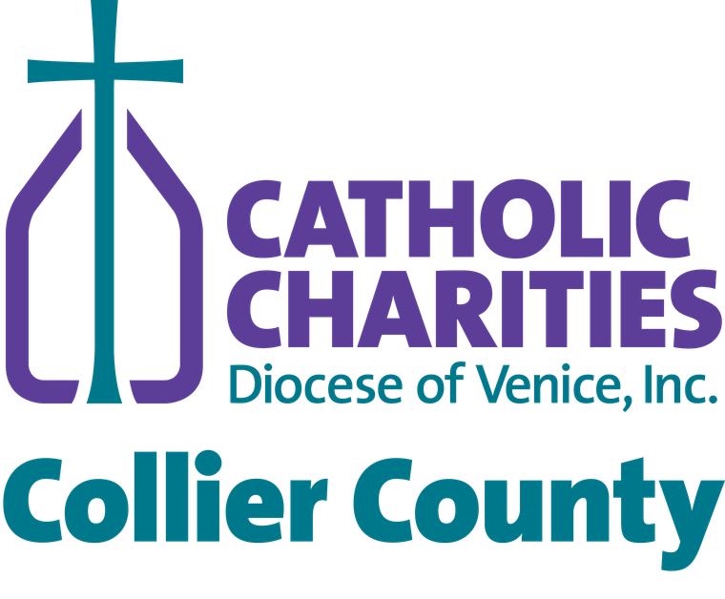



For over 30 years, our community has come together
to provide

elementary school children in Collier County with something every child
deserves—the comfort and dignity of new socks and underwear.
Please consider donating new, unused socks and underwear in children’s sizes
Small, Medium, and Large, and X-Large (ages 5–14).
Help us continue this

tradition of caring for children in our community.
UNDY SUNDAY

IS BACK!
Donate new socks and underwear for children

in Collier County!
WAYS TO GIVE
Bring new socks & underwear to
Church, Drop in bins by the exit
OCT. 17/18 & OCT. 24/25
DONATE ONLINE
Send an item from the
Amazon Wishlist
Make an monetary donation
to Catholic Charities

CCDOV.ORG
SCAN TO DONATE
Please contact Allegra: 239-793-0059 ext.3304
abelliard@ccdov.org
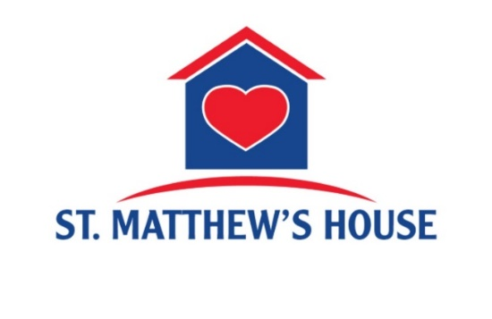

MISSION MESSAGE:
Our spotlight on St Matthew’s House is “shining into October" as we continue to support this important mission.
As you enter the church Narthex you are greeted with wonderful donations being collected for the homeless population in our community.
St Matthews House provides a safe haven for many people struggling without a roof over their heads.
They provide shower facilities for these individuals to come and feel safe and refresh, building trust so that someday some might seek help from some of the other programs at St Matthew’s House
We are supporting this “hygiene help” mission by collecting the following personal care supplies to donate:
- travel size shampoos and conditioner
- small soaps/body wash
- bath towels- can be gently used
Each person is offered a meal to go, another great way to show support and let people know they are valued and cared about.
Our Mayflower Mission Team has ordered insulated lunch bags that we will fill with donations of water and snack foods to supplement the “meals to go" that are provided.
- bottled waters
- granola bars
- packets of snack crackers, cheese/peanut butter
- trail mix snacks

- hand sanitizer/hand-wipes

Thank you so much for all the loving donations that are being collected for this very meaningful outreach. This will make a wonderful difference in many lives and help us serve people in need with loving compassion. Please consider writing a note of inspiration, a prayer, or perhaps including your favorite scripture, a poem, a hymn that will help lift someone’s spirits and let them know we care.
A box to collect notes will be on the St Matthew’s House table.
Thank you everyone for all you do ❤️



When a group from our church was able to tour the Women’s shelter we had the pleasure to meet several staff members, and we learned about ways that we could help volunteer at the shelter facility. The Healing Arts Advocate, Lisette let us know that several of the women were interested in learning how to make a basket. She explained that activities like sewing, art, knitting and crochet all help in the healing process. These activities help build self confidence as well as help individuals to concentrate and be fully engaged . So our basket making idea bloomed into a
wonderful class where thirteen women were able to gather together for the joy of making a bread basket. It took two classes to complete and was an absolutely fun success. One of the staff named Linda is a bread maker and surprised everyone with a loaf of sourdough bread for each of their baskets. The basket teachers were Linda & Bob Duck, Nancy Stephenson and Janice Cressman.
We each received a homemade beautiful thank you note signed by all the participants expressing their appreciation and how much they love their very own hand made basket❣️

Members from our church also donated 3 sewing machines and material for the women to use in their healing arts classes.

Thank you to everyone for your continued donations and time to help support this wonderful mission with such tender loving care.


The holiday season is just around the corner, and the Kris Kringle elves are already hard at work! Plans are underway for another festive fair filled with delicious food, fabulous raffle baskets, holiday treasures, and plenty of Christmas cheer.
One of our favorite Kris Kringle traditions is returning—our famous frozen dinners for two! Order forms for frozen dinners and baked goods will be available beginning October 11th, so start thinking about stocking your freezer and treating yourself to some homemade goodies. All orders are due by November 1st. Completed order forms may be dropped off in the office or on Sundays in the Narthex. You can also place your order electronically on the website starting October 11th.
Don’t forget those raffle tickets! Be sure to turn them in for your chance to win one of our fabulous baskets. Need more tickets? Pick up extras for family, friends, neighbors, and coworkers in the church office or see Linda Eddy. You never know who might be holding the winning ticket!
Our elves are putting the finishing touches on the raffle baskets, and a few more goodies would help make them extra special. Last-minute donations of gift cards, wine, ornaments, holiday decorations, wine glasses, and other festive treasures are still welcome. Please bring donations in by mid-October so the elves have plenty of time to work their Christmas magic and spruce up the baskets.
The Kris Kringle Fair is a wonderful way to kick off the holiday season, enjoy some delicious homemade favorites, and share a little Christmas spirit with friends and neighbors. So, get those dinner orders ready, return your raffle tickets, and help our elves finish filling those fabulous baskets.
Kris Kringle Fair
November 14, 2026
9:00 AM – 1:00 PM

From Prayer Team
I used to pray that God would feed the hungry, or do this or that, but now I pray that he will guide me to do whatever I'm supposed to do, what I can do. I used to pray for answers, but now I’m praying for strength. I used to believe that prayer changes things, but now I know that prayer changes us and we change things.
St. Mother Teresa



SUNDAY | MONDAY | TUESDAY | WEDNESDAY | THURSDAY | FRIDAY | SATURDAY
 |  |  |  | 1  Julie Martin - Birthday | 2  Birthdays – Robin Dick and Linda Saling | 3  Sandy Clary - Birthday
4  Worldwide Communion Sunday | 5  Joanne Spotts - Birthday | 6  Book Club 7pm  WM – Greenway Park | 7  Activities Team Meeting 3:30 pm  Potluck Supper 5pm | 8 | 9  Prayer Team Meeting 10 am | 10  Ladies Lunch at The Beach House 12 pm
11 | 12 | 13  WM – Freedom Park  Lifeline Screening Event | 14 | 15 | 16  Priscilla Hamilton - Birthday | 17
18 | 19 | 20  WM – Botanical Gardens | 21  Council Meeting 11:30 am | 22 | 23  Prayer Team Meeting 10 am | 24
25 | 26 | 27  WM – Eagle Lakes Park | 28 | 29  Julia Risher - Birthday | 30 | 31  

