The Masthead
The Newsletter of Mayflower United Church of Christ
2900 County Barn Road, Naples, FL 34112

(239) 775-0055 www.mayflowernaples.com Mayflowernaples@outlook.com
Office Hours: 8:00-1:00 Tuesday-Friday
September 2026

A message from Pastor Aaron Martin

It has been a fun summer getting acclimated with Mayflower! I started here in April, so many of you were travelling north right as I was getting started. I look forward to getting to know our seasonal folks better when you get back! I have spent most of my time trying to learn the culture and build relationships with those that are here. I can definitely say that this is the friendliest church that I have ever been inside of, let alone worked at.

I have started doing one contemporary song on the guitar each week and we have been going through different books of the Bible. We have gone through the book of Acts, the book of Jonah, and we are in the middle of looking at the gospel of Matthew. You can see any of our services on youtube. There is a link to the services on the website. We have seen 3 new families start coming through the summer, which is exciting. We will be starting the book of Esther in a few weeks as we gear up for the fall!

Worship Team

It is interesting watching Mayflower Congregational UCC on line. As a snow bird, it keeps us connected. It has been a pleasure to see Isabella flourish and her duet with Jay was a credit to her. I thank God for putting her in front of the search team as a musical director. If you have a musical talent or want to sing, please let us know. We would love to have you.

I am grateful for all the volunteers who greet, read and serve. It has been brought to our notice that the Pita Bread (to represent unleavened bread) has not been well received for communion bread. We will then return to our tasty white wonder bread for communion. We have a new greeter added to the list – welcome Val and also a new liturgist – welcome Cade If anyone else has an interest in reading and or greeting, please let me know so that I can add you to the list.

Activities Team 



FINANCIAL CORNER AS OF 8/25/26

Operating Account Balance
$217,537.44

Mortgage Account Balance
$81,964.56

Designated Account Balance
$27,835.71

Consider joining the Activities Team!
We welcome ideas for activities that will engage the congregation.

Come help us plan and carry out a variety of activities.

PROGRESS OF MORTGAGE PAYOFF PLAN

Mortgage Loan Balance
$85,250.94

Mortgage Account Balance
$81,964.56

Amount needed to pay off loan
We are now planning our Fall events, including the Kris Kringle
Fair on Saturday, Nov. 14. We are also exploring additional events to sponsor.
$3,286.38

If you are interested, please see Linda Eddy, Ginger Ribinski, Alice Upshaw, Janice Cressman, Candi Tipton, Judy Dudley or Lou D’Amico OR put it on your CONNECT CARD!



Whether you are creating your first will or reviewing an existing estate plan, taking time to ensure your wishes are current can provide peace of mind for you and your loved ones while strengthening the legacy you hope to leave behind.

In 2024, the National Ministries of the United Church of Christ and The Pension Boards-United Church of Christ launched Together for Tomorrow, an initiative designed to inspire and advance legacy giving Through our partnership, you have access to FreeWill, a complimentary estate-planning resource that can help you create or update your plans with intention. Thoughtful planning can help you care for your loved ones while supporting the church and causes that reflect your values.

This is a free service to encourage everyone to start their legal estate planning with access to a free will. You
may also create a free revocable living trust, if that suits your needs.

Don't let the state of Florida make your decisions. Be proactive and start planning now and for free. You can save attorney fees!


Get ready to jingle all the way to the Kris Kringle Fair! Mark your calendars for a day of holiday fun, fellowship and festive shopping on Saturday, November 14th from 9 AM – 1 PM. The elves are hard at work putting together the raffle baskets and preparing a variety of yummy treats. Raffle tickets are being prepared and will go in the mail September 11th. You will receive 25 tickets for your $30 donation. Write your full name and phone number legibly on each ticket and return them by mail, in the offering plate or in person. Don’t delay, if you are mailing your tickets, please do so by November 4th so they arrive on time. If you know someone who would like to participate, let us know and the elves will get tickets to them. So, don’t wait until Santa checks his list twice! Get your raffle tickets filled out and returned on time. Invite your friends and family to join us for the Kris Kringle Fair on November 14th. You could be one of our lucky
winners.



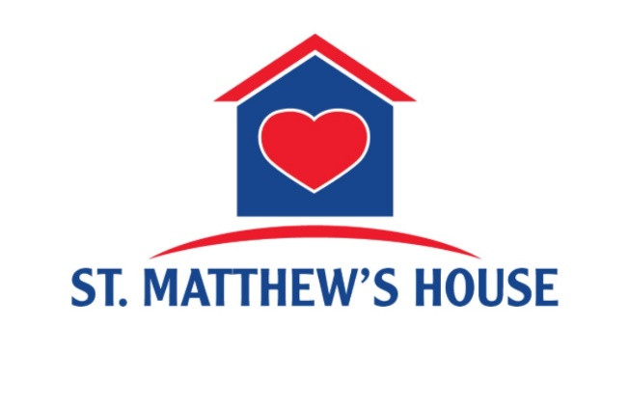

MISSION MESSAGE:
Our Mission Spotlight for the month of September is St. Matthew’s House
For over 38 years, St. Matthew's House has been fighting hunger, homelessness, and addiction in Southwest Florida. Through holistic programs and resources, we empower individuals by meeting immediate needs and focusing on building toward sustainable transformation. Our work is centered on one purpose: ensuring no one in Southwest Florida is without a pathway on their journey from crisis to contributor.
We serve those facing three of our community's most pressing challenges:
· Hunger — Nearly 152,000 individuals experience food insecurity in Southwest Florida every year.
· Homelessness — More than 3,200 adults and children experience homelessness in our communities.
· Addiction — Each year, Florida reports over 4,000 drug overdose deaths, among the highest totals nationally.

Programs
Food Assistance:
We work to eliminate hunger through our food ministry and food pantry. Last year, over 2.1 million meals were distributed.
Homeless Shelters:
As the only facilities of their kind, the Campbell Lodge in Naples and the Fort Myers Shelter for Women and Children provide critical resources to men, women, and children experiencing homelessness. Our shelters provide access to critical resources, job training and placement, educational opportunities, benefits enrollment, life-skills, financial literacy, spiritual development, legal assistance, and more. Last year, 1,595 people utilized our shelters, with over 741 moving from homeless to housed.

Addiction Recovery:
Justin's Place® is Southwest Florida's only year-long, faith-based 12-step recovery program. Justin’s Place is designed to empower participants to find freedom from their addiction. Spanning twelve months, the residential program integrates the 12 Steps, Biblical principles, and peer accountability. Through counseling, case management, peer support, and work therapy, participants begin moving from a position of crisis and instability to one of sobriety and restoration. Last year, St. Matthew’s House supported 1,253 people on their recovery journey.
Transitional Housing:
The two-year transitional housing program at St. Matthew’s House offers a supportive and empowering environment for individuals and families exiting our shelter and recovery programs. Wolfe Apartments and Justin’s Village operate as sober-living communities with sub-market rents, allowing residents to build credit as leaseholders and increase savings needed to achieve housing of their own. Last year, 250 people found supportive housing at a St. Matthew’s House property.
Workforce Development:
Our businesses and programs train and employ participants, equipping them with the skills and resources to secure stable employment in a multitude of careers. Last year, 681 individuals gained and retained jobs.
A Story of Impact: Jennifer's Journey
"I came to St. Matthew's House with my daughter, to get back on my feet. I am very grateful… very grateful. It has changed my outward look on life. I don't feel hopeless anymore."
— Jennifer, St. Matthew's House participant
Stories like Jennifer's are made possible because of communities like yours. When Mayflower UCC shows up — through your prayers, your gifts, and your hands-on service — you become part of someone's turning point. Thank you.
Thank You, Mayflower UCC
Your congregation's generous and faithful support over the years has helped us serve our neighbors when they needed it most. Whether through financial gifts, volunteer service, or simply spreading the word about our mission, Mayflower UCC has been an essential partner in making Southwest Florida a more compassionate community. We are committed to honoring that trust through transparent, impactful stewardship of every resource you entrust to us.

Mayflower church members have helped support St Matthew’s House in so many ways: Every year following our February Church Sale we donate all the furniture and household goods to St Matthew’s Thrift Store. On Souper Bowl Sunday we traditionally raise funds from the sale of homemade soups and breads where all proceeds are donated to St Matthew’s House.
Groups of our church members from mission tour activities and Bible Studies have attended LULU’S KITCHEN to show our support of their culinary team. We also donated an industrial mixer and culinary roasting units to the Catering team of Delicious By Design to help with their food service. For the past several years we have hired St Matthew’s House catering company to provide our Mayflower Church Thanksgiving Dinner celebration.

Ways to Get Involved:

Volunteer Your Time: St. Matthew's House relies on countless volunteers and the thousands of hours they give every year. Our volunteers come together in a faith-based environment to support those we serve. Opportunities include:
· Shelter Meal Service Ideal for groups!
· Outdoor Outreach Meal Service
· Food Warehouse and Pantry
· Vocational Training Coaches
· Shelter Childcare
· Fundraising Events & Operations Support
Host a Group Dinner at the Shelter: One of the most meaningful ways a church group can serve is by sponsoring and serving a dinner at one of our shelters. Your group will prepare, serve,, and even share an evening meal with residents. A simple act that communicates profound dignity and care. Ideally groups will commit to at least one day per month on the same days of the month for at least a three-month period.
Donate
Every dollar goes directly toward serving our neighbors — it only takes $41 a day to support someone on their journey from crisis to contributor.
Shop & Support Our Social Enterprises
Did you know that every time you shop or hire us, you're directly funding our mission? St. Matthew's House operates two thriving social enterprises — and every dollar they generate helps us serve more neighbors in need.
St. Matthew's House Thrift Stores
Discover hidden treasures and support a great cause at our upscale thrift stores! We offer name-brand clothing, furniture, home goods, and more at discounted prices — with new arrivals daily. We also offer pickup for donations and affordable delivery. Visit one of our convenient Southwest Florida locations: Naples Flagship · Golden Gate · Parkshore · Bonita Springs · Fort Myers
Delicious by Design Catering
Since 2005, Delicious by Design has been delivering award-winning catering — earning 5-star reviews and taking home the Best of Naples and Naples Daily News Choice Awards. From intimate gatherings to grand-scale events, every meal reflects our shared dedication to community and connection. Delicious by Design also supports outreach meals and a culinary training program for our participants.
Whether you're planning a church banquet, a corporate lunch, or a private celebration — consider choosing Delicious by Design and know that your event is making a difference.

Dear Mayflower UCC Congregation,


On behalf of the students and families we serve, thank you for supporting Guadalupe Center.
Your generous donation of $500.00 on July 22, 2026 to our Classroom Supply Collection ensures that the students in Immokalee have the tools they need to start the school year confident and prepared. Your support helps create a welcoming and well-equipped learning environment—one where students can focus on growing, exploring, and achieving their goals.

Each year, more than 2,000 students benefit from our high-quality academic programs, including Early Childhood Education, After-school Tutoring & Summer Enrichment, and Tutor Corps. Because of generous partners like you, students are entering kindergarten ready to learn, mastering core subjects, and earning college degrees—clear proof that consistent support creates lasting impact.
When you give to Guadalupe Center, you do more than donate supplies—you help remove barriers, build confidence, and open doors to a bright future.

Thank you for being part of each students success story.

Always,

Dawn Montecalvo
President

Dear Mayflower Church Congregation,
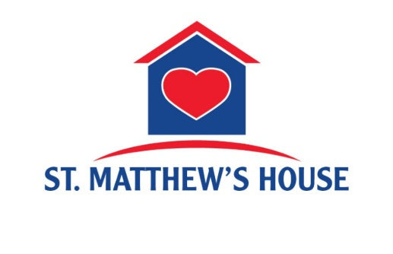
On behalf of St. Matthew’s House and the people we serve, thank you for your generous gift of $540.00 which was received on 7/27/2026. We are especially grateful to

share that your gift was “matched through our Summer Match Campaign”, effectively “doubling your impact”.

"Your donation gives hope;
It saves lives. Thank you”
—Wayne C.

With your support, we’re able to provide immediate relief to those experiencing hunger, homelessness, and addiction while also giving them hope and opportunities to find

long-term transformation. Your faithfulness continues to make a difference.

Yours Sincerely,

Ben Bridges, President and CEO
St. Matthew’s House

Dear Mayflower Church Members



On behalf of everyone at Grace Place, thank you for being a part of our Back to School Bash!

Despite the heavy rain and unexpected weather, your generosity, flexibility, and enthusiasm helped make the event a success. Thank you for the time, services, and resources you shared with our community! Your partnership made a meaningful difference for the families we serve. We also provided more than 500 backpacks during the event, and the remaining 300 were distributed to families throughout this week, ensuring even more students are prepared for the new school year.

I've included photos from the event below; we hope you enjoy looking back on the day and seeing the impact of your support. We look forward to partnering with you again in the future!

Kailyn Potter
Volunteer and Internal Events Manager
Grace Place for Children and Families

Dear Mayflower Cookie Elves,

Many thank you’s for all the hard work and loving hands that helped provide 1000 cookies for us to distribute at the Grace Place Back to School Bash.

We also shared cookies with the Shelter for Abused Women and Children and the Guadalupe Center Children and Families.

Your kindness brought smiles to many and lifted spirits knowing that we care about them.

Everyone really appreciated all you did and enjoyed the delicious snacks🍪
Thank you,
Mayflower Missions Team

pICTURES FROM THE bACK TO SCHOOL BASH
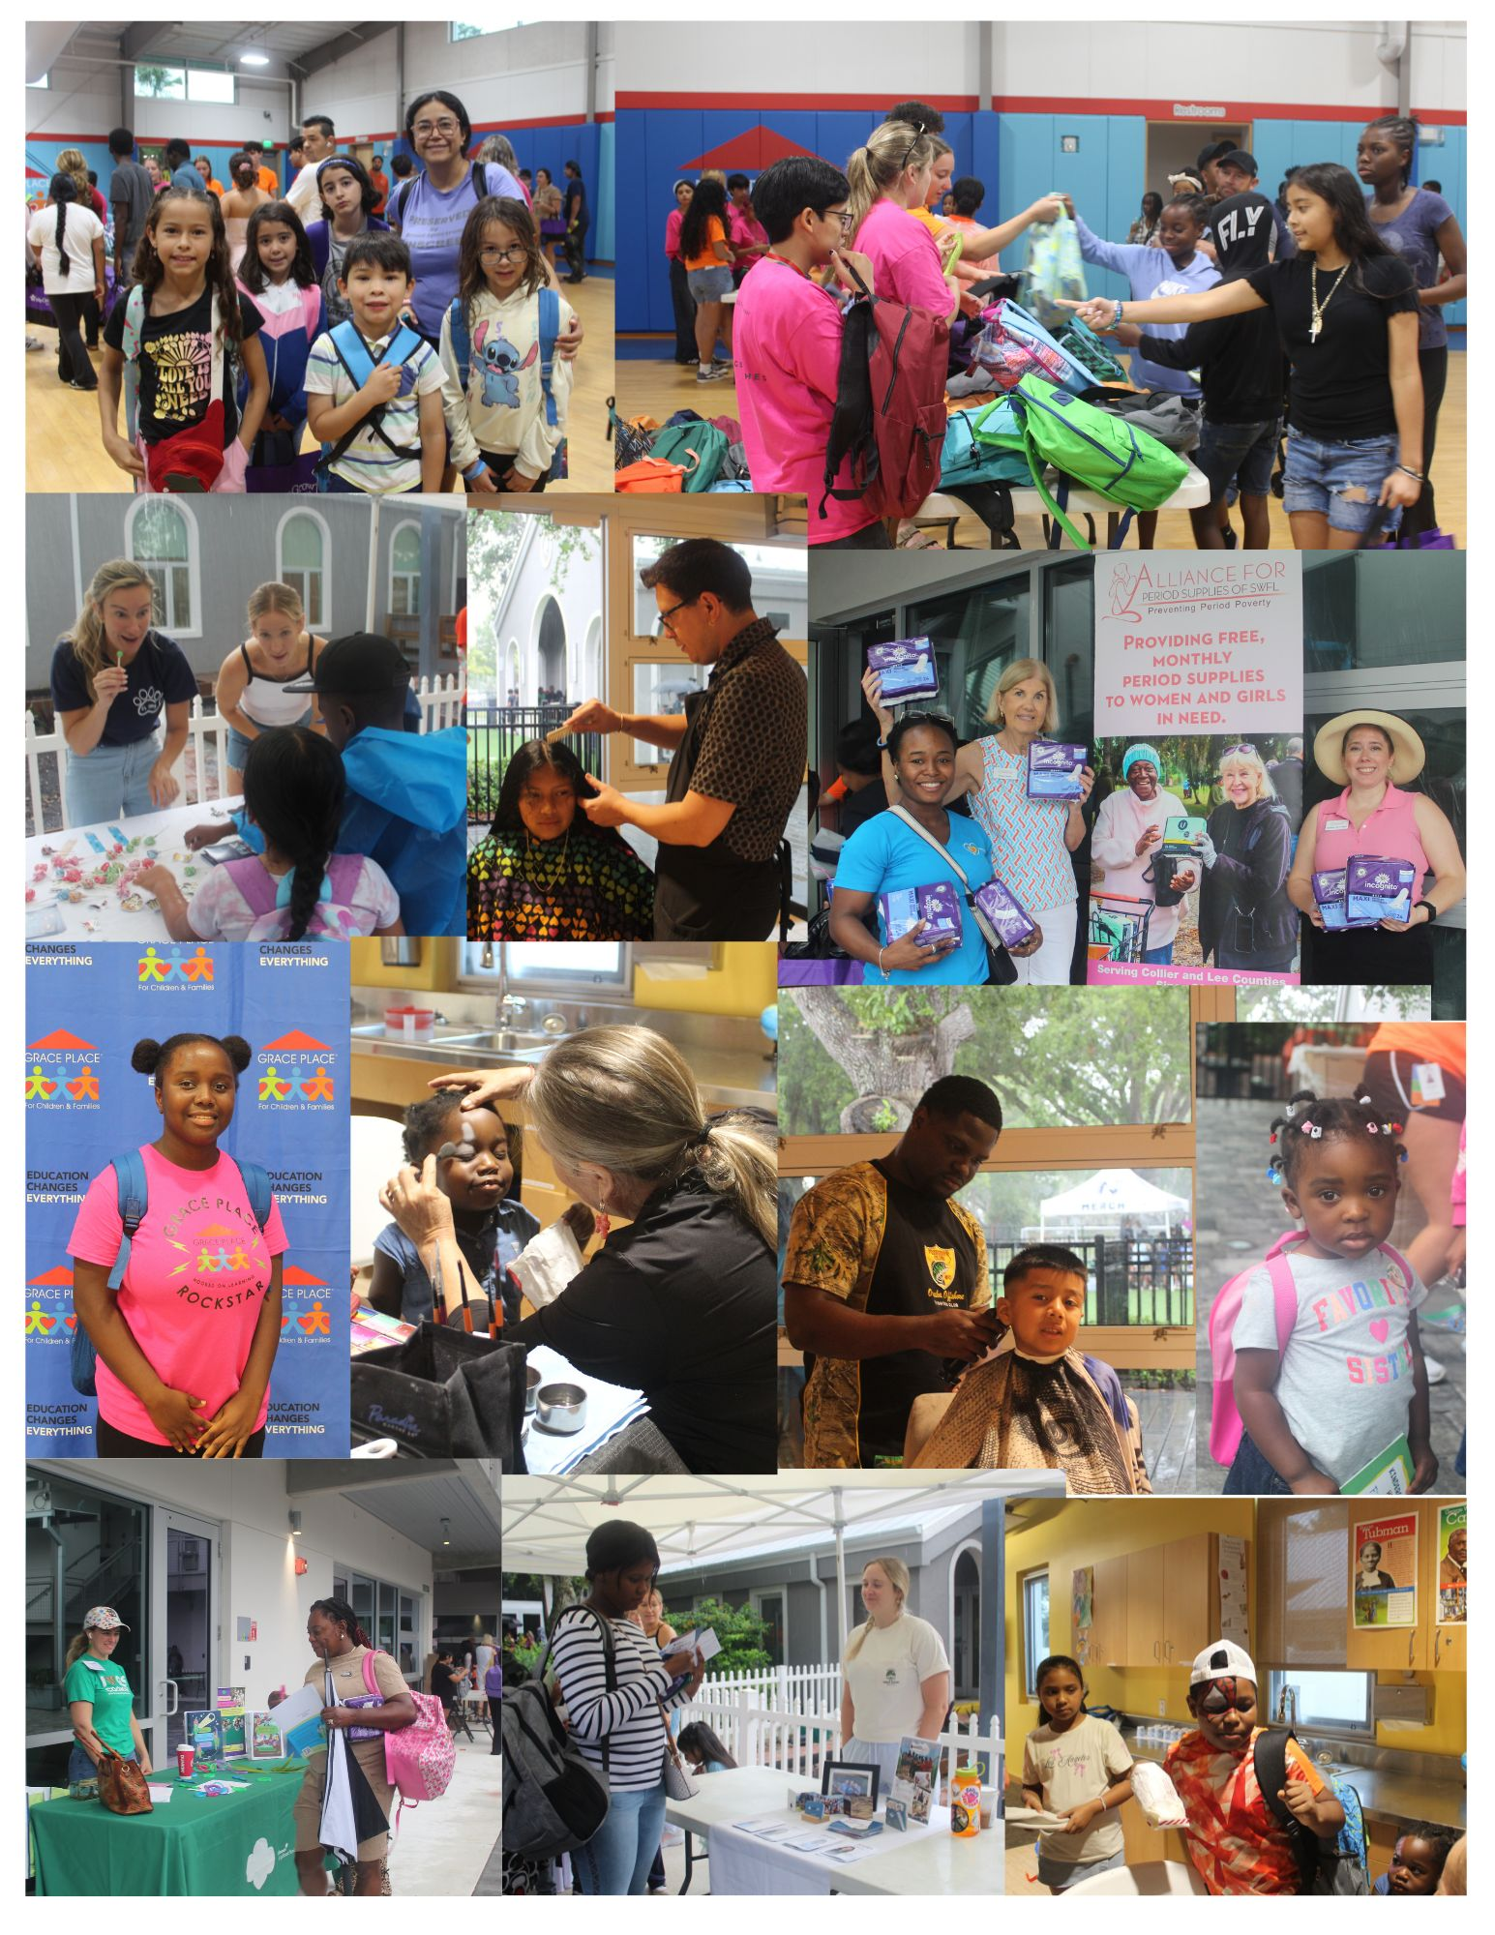



Murder Mystery Event- Murder by BINGO,

September 19, 2026
3:00 PM
Witness a murder by Gibson House Mystery Performers!
Join us and help us solve this hilarious crime!
It’s time to play BINGO at The Marco Island’s Art Center Theatre Hotel.
The assistant Hotel Manager, HOLLY DAYIN is doing her best to make everyone happy. She is checking in everyone as fast as she can with the bell boy’s, OLIVER SUDDEN, assistance. Hotel guests include – ANNIE BUDDYHOME and ROYAL PAYNE. They are both very anxious to see FAYE SLIFT’s performance that evening …….. or do they want to see her for a different reason? Let’s hope Faye Slift doesn’t disappoint anyone, including her manager, EARL E. BIRD. (BINGO is played throughout the night until the game is won.) Cost will be $42.85

For more information, to sign-up, or to carpool, talk with Lou (239-455-7156).
Sign-ups will be on Sunday, September 6 after church.


SUNDAY | MONDAY | TUESDAY | WEDNESDAY | THURSDAY | FRIDAY | SATURDAY
 |  | 1 | 2  Peggy Littlejohn – Birthday  Potluck Supper 5 pm | 3  Robin & Jean Dick - Anniversary | 4 | 5
6 | 7   | 8  Book Club 7pm | 9 | 10 | 11  Prayer Team Meeting 10 am   | 12  Ladies Lunch at The Beach House 12 pm
13 | 14 | 15 | 16  Council Meeting 3:30 pm | 17 | 18 | 19  Birthdays – Janice Cressman & Nancy Sherwood
20 | 21  Jane Thompson - Birthday | 22   | 23  Masthead Deadline | 24  Marlin & Marilyn Dise - Anniversary | 25  Prayer Team Meeting 10 am | 26  Scott Casey - Birthday
27 | 28 | 29 | 30

